**Nouveau Roman**

The “Nouveau Roman” or “New Novel” is used to refer to a literary and critical movement in France during the 1950s and early 1960s. Although the Nouveau Roman quickly became associated with the work of Alain Robbe-Grillet, Marguerite Duras, Nathalie Sarraute, Michel Butor, Claude Simon, Claude Mauriac, and Robert Pinget, to name only the most notable, it never crystallized into so dogmatic an ideology of literature and art as had the Surrealism of Andre Breton during the 1920s and 1930s. To a large extent, the term “Nouveau Roman” was a fabrication of the popular press in France. Articles and interviews, manifestos and polemical attacks did however appear in the more specialized journals of *Les Temps Modernes* and *Tel Quel*, and it is here that the aesthetic and theoretical principles of the Nouveau Roman were subjected to more nuanced critical discussion and debate than was otherwise possible in popular media outlets such as *L’Express* or *Le Monde*.

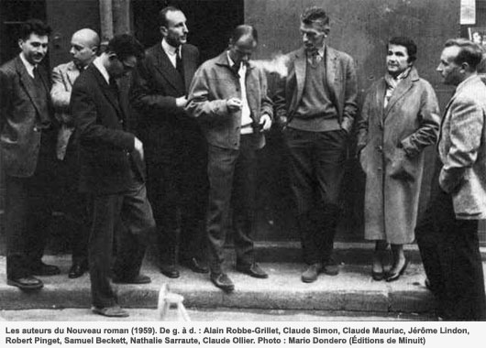

<http://www.pileface.com/sollers/IMG/jpg/pf_nouveau_roman_1959_2.jpg>

The Nouveau Roman challenged not only the aesthetics of the novel that was dictated through the ideology of literary realism, but it also took aim at Jean-Paul Sartre’s politically-minded doctrine of “committed literature”, developed in his 1947 publication of *What is Literature?*. Proponents of the Nouveau Roman suspected Sartre of sacrificing the autonomy of literature to causes of political propaganda in post-Occupation France. Insofar as the Nouveau Roman desired to distance itself from the cultural influence of the Sartrean theory of committed literature, it did so by placing an uncompromising emphasis on the formal aesthetics of the novel, which the nouveaux romanciers believed themselves to be capable of perfecting. Robbe-Grillet in particular insisted that the novelist could only be committed to literature. In the spirit of a cultural homage to Gustave Flaubert, who was perhaps the first French writer to take the genre of the novel as a serious art-form in its own right, the novelists of the Nouveau Roman similarly envisioned the novel-form as an aesthetic object that was cut off completely from the political and historical contexts that otherwise enveloped the conditions of its composition. Inspired also by the publication of Samuel Beckett’s *Molloy* and Eugene Ionesco’s *Bald Prima Donna*, both of which appeared in 1950, French novelists committed to the formal ideal of the Nouveau Roman set out to write novels that did not have to answer for or seek to transform the ethical or philosophical shortcomings of the world external to the novel.

Accordingly, the Nouveau Roman gave birth to novels that tended to be austere in their tone and that showed a disregard for the characteristic tropes of realist literature (metaphor, simile, etc.). Instead, the Nouveau Roman prized itself on adhering to strict physical descriptions of the settings and characters that animated its diverse narrative structures. On top of this, the Nouveau Roman also showed an unparalleled commitment to ambiguity of interpretation, disjunctive representations of space and time, and self-reflexive digressions on the complexities of literary composition. The Nouveau Roman, in short, dispensed with virtually all of the techniques that had hitherto assisted readers in distinguishing between reality and fiction, writer and character, and even the reader and the characters trapped, as in the case of Robbe-Grillet’s *In the Labyrinth*, within the texture of the Nouveau Roman itself. One of the lasting accomplishments of the Nouveau Roman was to successfully blur the lines between literature and theory, novelist and critic. The Nouveau Roman is viewed by many commentators as a transitional aesthetic between modernism and postmodernism.

**References and Further Reading**

Britton, Celia. *The Nouveau Roman: Fiction, Theory and Politics*. New York: St. Martin’s Press, 1992.

Heath, Stephen. *The Nouveau Roman: A Study in the Practice of Writing*. Philadelphia: Temple University Press, 1972.

Jefferson, Ann. The Nouveau Roman and the Poetics of Fiction. New York: Cambridge University Press, 1980.

Oppenheim, Lois, Ed. *Three Decades of the French New Novel*. Urbana: University of Illinois Press, 1986.

Robbe-Grillet, Alain. *For a New Novel: Essays on Fiction*. Trans. Richard Howard. New York: Grove Press, 1965.

**List of Selected Works**

Butor, Michel. *Two Novels:* Passing Time *and* A Change of Heart. Trans. Jean Stewart. New York: Simon and Schuster, 1969.

Robbe-Grillet, Alain. *Two Novels:* In the Labyrinth *and* Jealousy. Trans. Richard Howard. New York Grove Press, 1965.

--. *Last Year at Marienbad*. Trans. Richard Howard. New York: Grove Press, 1962.

Saurraute, Nathalie. *The Planetarium: A Novel*. Trans. Maria Jolas. London: John Calder.

Simon, Claude. *The Invitation*. Trans. Jim Cross. Elmwood Park: Dalkey Archive Press, 1992.